BIT – IT, Fiscal and Accountancy Services
Piotr Żakowiecki
ul. Ks. Hugona Kołłątaja 9/6
91-427 Łódź
NIP: 725-169-49-14

Marina computerization offer

* * *
„e-Marinas”
Computer System to support Sea and Inland Marinas

* * *

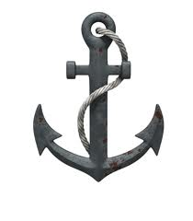

April 2017

1. Brief description of „e-Marinas” system.

2. Most important features of „e-Marinas”.

3. How „e-Marinas” came to life. An idea.

4. Compatibility with fiscal devices.
- fiscal printers
- cash registers

5. Compatibility with finance and accounting systems.

6. „e-Marinas” in computer network.

7. System requirements.

8. A few words about BIT company.

9. Software and hardware service.

1. Brief description of „e-Marinas” system.

“e-Marinas" software has been devised to help with management of marinas. It helps providing service to customers - incoming and outgoing ships, keeps record of ships in docking in marina and all sort of additional services provided by marina like slipping, yacht winterizing, showers, toilets.

“e-Marinas” enables its users obtaining full and easily accessible information about docking yachts and their payment status.

There is a wide range of searching options including yacht name, name of captain, name of company, docking dates etc.

The System supports all kind of financial operations – receipts, invoices, payment records etc. All these documents can be printed, saved on hard disc or automatically sent to customer.

A very important and useful feature of “e-Marinas” is its reporting and informing module. The System includes many useful reports and is open to modifications reflecting customer’s individual needs.
The System updates in real time information about amount of cash in cash register, amount of cash in possession of each bosun, current bosun deposits.

Every report can be shown on computer screen, printed, saved on hard disc or automatically sent by e-mail to the office, if needed.

"e-Marinas" software has its own yacht charter service module. Built-in callendar assists reservation of charters; the System prevents reservations from duplication. This module helps serving clients – it records customer data, prints charter contracts, monitors payments etc.

2. Most important features of „e-Marinas”

Record Management of incoming and outgoing vessels – Port Book
- instant and full information about all yachts in port
- the system shows yachts with pending and overdue payments
- simple and easy searching options including yacht name, captain’s name, dates etc.

Records can be kept in two ways:

- On top of saving basic information about incoming yacht (name, captain, ship-owner, company, number of crew members, additional information etc.), customer can mark parking space where he wants his yacht to be berthed just by clicking on appropriate space on the map provided. This way user obtains graphic illustration of yachts' location in the port.

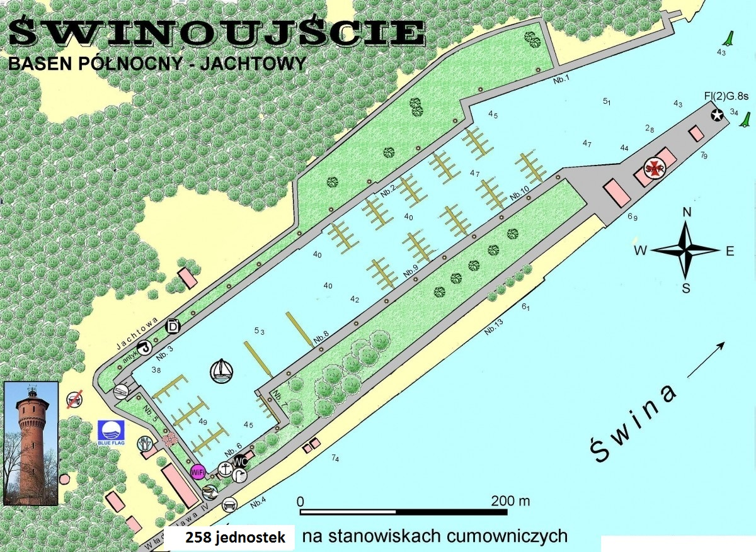
The system shows on-line number of vessels and their location in the port.

- Record of incoming yachts can also be used to save necessary information about each yacht without specifying berthing place.

Payments suport

- berthage payment records (cash receipts, proofs of payment)
- payments records of additional services e.g. toilets, showers, yacht slipping, carpark etc. (cash receipts, proof of payments)

Deposit Support (deposits of keys, access cards, electricity and water cards etc.)
- the system shows pending payments of each yacht
- the system provides information about number and amount of current deposits
- deposit records in all currencies

Invoices

- the system automatically prints invoices upon receipt of payment for provided services
- the system prints invoices for earlier provided services on basis of presented cash receipts. In this case there is no need to re-enter data – all necessary information are already in the system.
- the system prints invoices for any services provided by the port
- invoices can be printed, saved on hard disc or automatically sent to client by e-mail.

Residents Support

- making contracts for residents
- the system monitors termination of pending contracts
- automatic renewal of contracts
- drawing up payment documents for berthage (cash receipts, invoices)
- the system reminds about pending payments or next instalments
- automatically prints invoices when next instalment is due to be paid
- automatically sends out invoices by e-mail
- allocation of berthing places in a marina (interactive map of port with free/occupied places).

Payment Settlements

- handling of invoices with extended payment date
- monitoring pending payments
- informing customers about pending payments
- printing payment reminders or automatic sending them by e-mail
to customers

Reports

- all reports can be generated for any period of time (monthly, quarterly, half-yearly, annual) including among others:
- financial reports ( invoice & VAT registers)
- cash reports (cash in possession of each boson, taking amounts , revenues)
- register of cash invoices
- register of extended payment date invoices
- register of invoices for each individual customer
- revenue reports for all services provided in port
- statistics reports
- all reports can be shown on computer screen, saved on hard disc or automatically sent out by e-mail, for example to the office.

Global Reports - "e-Marinas" is prepared to operate many marinas connected by computer network (point 6. "e-Marinas" in computer network). This feature will allow to generate reports from all marinas working in the system in one place.
Without leaving the office the user can obtain information about number of yachts currently docking in every marina. The user can check current amount of takings in every marina as well as for each bosun separately. Additionally the System generates financial, accounting and statistics reports.

As creators of "e-Marinas" we will develop reporting possibilities of our software and create additional reports suited to individual needs of each of our customers.

Database – "e-Marinas" has been equipped with set of databases of countries, cities, streets, yacht types etc. This helps and speeds up entering data as well as minimizes possibilities of mistakes. These databases are being upgraded every day which means they are well suited for the needs of each marina.
What's more, databases of customers, captains, yachts are also developed the same way, which speeds up everyday work. For example drawing up invoice for a customer that is already in database requires only a couple of clicks, there is no need to enter all data every time.

3. How „e-Marinas” came to life. An idea.

"e-Marinas" software HAS NOT BEEN developed behind a desk or created by an IT theoretician .
The idea of "e-Marinas" has been born on the water, on a yacht, while sailing from one port to another in order to find free space, open shop, fuel... It has been developed in marinas during several, long lasting processes of registration at bosun’s, waiting for invoice, leaving e-mail or mail delivery addresses to receive invoice by traditional mail that sometimes never came.

The System was created to eliminate all inconvenience and difficulties. Thanks to this software we can be easily and quickly served at bosun's, invoice will be printed immediately or sent by e-mail.
There will be no more mistakes with berthing time in the port, no more awkward situations when we could be requested to pay for the second time etc.

The idea of “e-Marinas” has been masterminded by the BIT company owner – Piotr Żakowiecki, IT specialist and economist; yacht captain with passionwho annually sails over 5.000 nautical miles in the Baltic Sea, North Sea, Adriatic and of course his favourite Polish lakes – the Masuria Lake District, Jeziorak, Solina and others.

4. Cooperation with fiscal devices.

- Fiscal printers.

"e-Marinas" is compatible with POSNET and NOVITUS fiscal printers . BIT Company has all necessary permissions to instal and service these devices.

Connecting fiscal printer is very simple. All that needs to be done is physically connect fiscal printer to the computer, choose which printer you want to use in software options and …… done!
Fiscalisation runs automatically. Entering any payment into the system (e.g. berthage, shower, carpark payments etc.) automatically produces a receipt for customer.

You can use a fiscal printer which you already have or buy a new one. These are examples and prices of fiscal printers:
POSNET  Temo HS - Bileterka  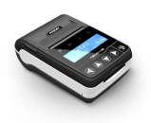  1.999,- PLN + VAT | POSNET  Thermal FV EJ  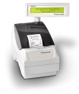  2.599,- PLN + VAT | POSNET  Thermal HS EJ  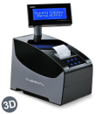  2.699,- PLN + VAT
NOVITUS  Deon E  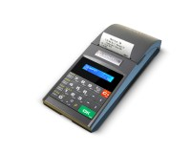  2.290,- PLN + VAT | NOVITUS  Bono E  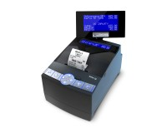  2,490,- PLN + VAT | NOVITUS  Delio Prime E  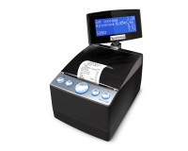  2.790,- PLN + VAT

- Cash register.

Any kind of cash register can be used with the System.

While working with cash register, payment that is entered into the System is not automatically processed (this is due to the fact that it is not possible to connect cash register to computer). Such transaction has to be separately entered into cash register which can be a nuisance in a long run and may create room for mistakes (differences between report from cash register and report generated by the System). That is why we strongly suggest fiscal printers instead of cash registers.

5. Cooperation with finance and accounting systems.

There are plenty of finance and accounting systems available on the market already used in marinas offices. "e-Marinas" can generate files with financial information
(invoices, cash receipts etc.) which can be later on uploaded into finance and accounting programs. There is no need to re-enter data into such programs.

BIT Company offers installa tion of "Symfonia" and "Optima" financial and accounting systems.

6. „e-Marinas” in computer network.

Using computer networks (local – LAN, WLAN, WAN – internet) the System can work with unlimited number of computers. It is possible to work with several computers within one marina or use the program in completely different places, such as an office far away from the marina or at home. Owners of several marinas can have direct insight into their marinas from their home or office.

Stand-Alone Version – working on one computer in a marina

MARINA 1
STANOWISKO
ROBOCZE

Multi-User Version – computers connected by local network (LAN or WLAN) – this allows working on many computers in a marina
MARINA 1
STANOWISKO 1
STANOWISKO 2
STANOWISKO X

Multi-User Version – computers connected by internet - one computer in a marina that is connected to office or home computer via internet. Office computer has direct access to all of the data so user has full information about what is going on in marina.

MARINA 1
STANOWISKO
ROBOCZE
BIURO POZA
MARINĄ
STANOWISKO
ROBOCZE
Połączenie internetowe

Multi-User Version – working with several computers and the ability to connect office/home computer. Connection via local network (LAN) or internet.

MARINA 1

STANOWISKO 1
STANOWISKO 2
STANOWISKO X
BIURO POZA
MARINĄ
STANOWISKO
ROBOCZE
Połączenie
internetowe

Multi-user version for several marinas – an office computer can be connected to one or two or more marinas and show on-line information from each of them,
We have also developed summary reports that include several marinas. Reports are made in one place (e.g. office) and can include berthage, carpark, media revenues from all marinas, VAT records etc.

MARINA 1
STANOWISKO
ROBOCZE
MARINA 2
STANOWISKO 1
STANOWISKO 2
STANOWISKO X
BIURO POZA
MARINĄ
STANOWISKO
ROBOCZE
Połączenie
internetowe

7. System requirements

minimal:
Processor: Pentium 4 2,0 GHz
Memory RAM: 1,0 GB
Hard Drive Space 4,0 GB

recommended:
Processor: dual core 64-bit lub or better
Memory RAM: 4,0 GB or more

Operating system:
Windows XP, Windows VISTA, Windows 7, Windows 8, Windows 10, LINUX

"e-Marinas" is based on MySQL Community 5.7.11. database.

8. A few words about BIT Company.

The Company was founded in 1991 under the name "BIT" as a partnership operating in IT and electronics. First developed software was named "Inspector" – insurance policies and damage liquidation system for PZU S.A., that was implemented in over 250 PZU branches all over Poland.
Since the very beginning the Company was focused on developing software using unorthodox solutions for more sophisticated customers.
Since 1996, when using phone number allowed to connect computer to internet, BIT started developing software that was not only based on local network but also software using internet (ticket-selling program that allowed tickets to be bought in one cinema for a movie in any other city). This technology is used also in "e-Marinas" (connecting several marinas and access to any of them from one place (office etc.).

Ever since the use of cash registers or fiscal printers became mandatory for
Polish entrepreneurs, every software developed by BIT Company has been compatible with fiscal printers. Obviously, so is "e-Marinas". The Company as well as its servicemen, have all necessary permissions and skills to instal, implement and service POSNET and NOBITUS devices.

Company name:
BIT - IT, Fiscal and Accountancy Services
Owner of The Company - Piotr Żakowiecki; since 2007 yacht captain

NIP:
725-169-49-14

REGON:
472044687

Account number:
Volkswagen Bank Polska S.A. nr: 87 2130 0004 2001 0355 7600 0001

Adress and telephone:
ul. Ks. H. Kołłątaja 9/6
91-427 Łódź
tel. +48 601 61 21 81 - owner
tel. +48 691 62 05 89 - service

e-mail:
info@e-marinas.eu
zakowiecki.piotr@e-marinas.eu

9. Software and hardware service.

BIT Company provides Nationwide Service of hardware and software, including:

• at your disposal are professional servicemen 7 days a week that can solve any problem:

• we guarantee that, if needed, our employee will reach any place in the country at the latest of 2 pm the day after notification and solve the problem

• if problem cannot be solved at location, we provide backup hardware

• we suggest agreement on permanent cooperation and remote software service via internet

We offer installing software that allows access to your computer 5 minutes after the notification, no matter the distance.

Offered software works through the internet in order to access computer remotely.

